Uploading File using AutoIT software
----------------------------------------------------------------

- Download AutoIT from the following link
https://www.autoitscript.com/site/autoit/downloads/

- From the above link download AutoIT and SciTE4AutoIt3
[AutoIt -> Downloads -> AutoIt]
[AutoIt Editor -> Downloads -> SciTE4AutoIt3.exe]

3. After download ,install both the setup one by one.

4. Go to the webpage where we need to upload the file and open the element Identifier by
double clicking Au3Info.exe file.

5. Open the browser window by clicking the upload button.Now drag the finder tool from the
identifier and place on the filename text box .Note the title & class and instance of Basic
control info.

6. Similarly note the title,class and instance for open button.

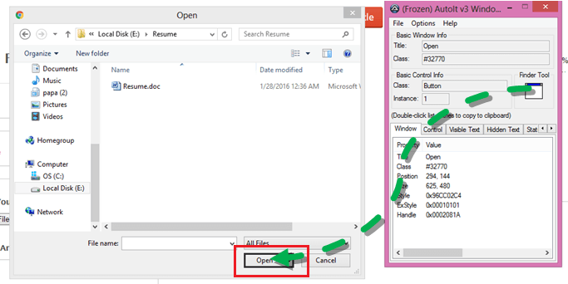

7. Now open the AutoIT editor by double clicking the SciTE.exe file and write the following
code,

ControlFocus("Open","","Edit1")
ControlSetText("Open","","Edit1","E:\Pictures\Penguins.jpg")
ControlClick("Open","","Button1")

8. In the above code Open(Title) may vary based on browser window and give the location of
the file to be uploaded.

  - Once done ,save the script by giving the required location.( For eg: FileUpload)

10. Now go to that location and complie the file (Rightclick on the file and select compile
script x64 ( 64-bit ) .Now FileUpload.exe file will be generated.

11. Now we can use the AutoIt script in selenium webdriver by using the following code ,

